|  |
| --- |
| **St. Basil the Great**  ***MELKITE GREEK CATHOLIC CHURCH***  **901 Sherman Drive, Utica, NY 13501**  **Telephone Number: 1 (315) 732-4662**  **Email: fatherthomasmoses@gmail.com**  **Website: stbasilutica.org**  **PARISH ADMINISTRATOR**  **Rev. Thomas A. Moses**  **WEEKEND VISITING CLERGY:**  **Rt. Rev. Philip Raczka Rev. Bryan McNeil Rev. Oliver Black**  ***"Enter the Church and repent ... for here is the physician, not the judge. Here one is not investigated, one receives remission of sins."***   * **St. John Chrysostom**   **Monthly Bulletin: May 2022**  ***Parish Advisory & Finance Council:***  ***Maryann Astour (Chair), Albert Casab, Janet George, Robert Lalli,***  ***Michelle Roth, Anthony Showa, Robert Zaloom***  **HOLY MYSTERY OF CONFESSION: Before or after any service, or by appointment;**  **HOLY MYSTERY OF CHRISTIAN ILLUMINATION: Please contact the pastor in advance to arrange for the required baptismal preparation and formation;**  **HOLY MYSTERY OF CROWNING: At least six months prior to the proposed wedding date, please contact the pastor to arrange for the required interview and sacramental preparation and formation;**  **HOLY MYSTERY OF THE ANOINTING OF THE SICK: Please contact the pastor at any time when this sacrament is needed. The pastor will make attempt to provide himself or arrange for another priest to provide the sacrament of anointing;**  **HOLY COMMUNION FOR THE SICK: Anyone too infirm to attend our services may receive the Eucharist in their home or in a local hospital. Please advise the pastor when the sacrament is needed.**  **FUNERALS AND MEMORIAL SERVICES: Please contact the pastor to plan arrangements to provide a proper burial and honor the memory of our beloved departed.**  ***Please remember to contact the pastor if a loved one is in the hospital and would like a visit from the priest. The hospitals do not always notify the church!*** |



**Sunday, May 1, 2022**

**Sunday of the Myrrh-Bearing Women**

**Commemoration of the Holy Prophet Jeremias**

**AFTER BLESSED IS THE KINGDOM:**

Christ is risen from the dead… 3x

**Antiphon of the Pascha**

1. Shout joyfully to God, all you on earth.

O Son of God, who are risen from the dead, save us who sing to You, Alleluia

1. Sing praise to the glory of His name; proclaim His glorious praise.
2. Say to God how tremendous are Your deeds! For Your great strength, Your enemies fawn upon You.

Glory be…. Now and always… O Only-begotten Son…

**Troparion of the Resurrection (Tone 2)**

**Troparion of Joseph (Tone 2)**

The Noble Joseph, taking down your spotless body from the wood

and wrapping it in a clean shroud with aromatic spices, laid it in a new tomb.

But on the third day, You arose, O Lord, and bestowed great mercy upon the world.

**Troparion of the Myrrh-bearers (2nd Tone)**

The angel stood by the tomb and cried out to the Myrrh-bearing Women:

“Myrrh is proper for the dead, but Christ has proved Himself free from corruption.

Cry out, then: “The Lord is risen and has bestowed great mercy upon the world.”

**Troparion of St. Basil the Great (Tone 1)**

**Kondakion of Pascha (Tone 2)**

Though You went down in the tomb, O immortal One, You overthrew the power of Hades and rose victorious, O Christ God. You greeted the ointment bearing women, saying “Rejoice!”

You gave peace to Your apostles, and to those who had Fallen resurrection.

**TRISAGION:**

All of you who have been baptized…

**PROKIMENON**

My strength and my courage is the Lord, and He has been my Savior.

***Stichon:*** The Lord has chastised me through His teaching, yet He has not delivered me to death.

**READINGS**

**Epistle:** Acts 6:1-7 **Gospel:** Mark 15:43-47; 16:1-8

**Hirmos of Pascha (Tone 1)**

The angel cried out to the one who is full of grace: “Hail, immaculate Virgin!”

Hail again, for on the third day your Son is risen from the tomb on the third day.

Shine, shine, O New Jerusalem, for the glory of the Lord has shown upon you. Rejoice and be glad, O Sion, and you, O pure one. O Mother of God, exult in the resurrection of your Son.

**KINONIKON:**

Receive the Body of Christ and taste the Source of Immortality. Alleluia.

**AFTER COMMUNION:**

Christ is risen from the dead…1x

**AFTER THE AMBON PRAYER:**

Christ is risen from the dead… 3x

**INSTEAD OF: THROUGH THE PRAYERS OF OUR HOLY FATHERS**

Christ is risen from the dead… 1x



**Sunday, May 8, 2022**

**Sunday of Paralytic**

**Commemoration of the Holy, Glorious and Illustrious Apostle and Evangelist**

**John the Theologian, and of our Holy Father Arsenios the Great**

**AFTER BLESSED IS THE KINGDOM:**

Christ is risen from the dead… 3x

**Antiphon of the Pascha**

1. Shout joyfully to God, all you on earth.

O Son of God, who are risen from the dead, save us who sing to You, Alleluia

1. Sing praise to the glory of His name; proclaim His glorious praise.
2. Say to God how tremendous are Your deeds! For Your great strength, Your enemies fawn upon You.

Glory be…. Now and always… O Only-begotten Son…

**Troparion of the Resurrection (Tone 3)**

**Troparion of St. John the Apostle (Tone 2)**

Apostle beloved of Christ God, hasten to sav a people that has no other recourse: for He who let you repose on His breast will also accept your intercession in our favor. O John the Theologian, beseech Him to dispel the cloud of paganism that is darkening us, and beg Him to grant us peace and mercy.

**Troparion of St. Basil the Great (Tone 1)**

**Kondakion of Pascha (Tone 2)**

Though You went down in the tomb, O immortal One, You overthrew the power of Hades and rose victorious, O Christ God. You greeted the ointment bearing women, saying “Rejoice!”

You gave peace to Your apostles, and to those who had Fallen resurrection.

**TRISAGION:**

All of you who have been baptized…

**PROKIMENON**

Through all the earth, their voice resounds, and to the ends of the world their message.

***Stichon:*** The heavens declare God’s glory and the firmament proclaims the work of His hands.

**READINGS**

**Epistle:** 1 John 1:1-7 **Gospel:** John 5:1-15

**Hirmos of Pascha (Tone 1)**

The angel cried out to the one who is full of grace: “Hail, immaculate Virgin!”

Hail again, for on the third day your Son is risen from the tomb on the third day.

Shine, shine, O New Jerusalem, for the glory of the Lord has shown upon you. Rejoice and be glad, O Sion, and you, O pure one. O Mother of God, exult in the resurrection of your Son.

**KINONIKON:**

Receive the Body of Christ and taste the Source of Immortality. Alleluia.

**AFTER COMMUNION:**

Christ is risen from the dead… 1x

**AFTER THE AMBON PRAYER:**

Christ is risen from the dead… 3x

**INSTEAD OF: THROUGH THE PRAYERS OF OUR HOLY FATHERS**

Christ is risen from the dead… 1x



**Sunday, May 15, 2022**

**Sunday of the Samaritan Woman**

**Commemoration of our Holy Father Pachomios the Great**

**and of our Father among the Saints Achillios the Wonderworker, Bishop of Larissa**

**AFTER BLESSED IS THE KINGDOM:**

Christ is risen from the dead… 3x

**Antiphon of the Pascha**

1. Shout joyfully to God, all you on earth.

O Son of God, who are risen from the dead, save us who sing to You, Alleluia

1. Sing praise to the glory of His name; proclaim His glorious praise.
2. Say to God how tremendous are Your deeds! For Your great strength, Your enemies fawn upon You.

Glory be…. Now and always… O Only-begotten Son…

**Troparion of the Resurrection (Tone 4)**

**Troparion of Mid-Easter Season (Tone 8)**

O Savior, at the middle point of this festive season, give my thirsty soul to drink from the waters of piety and devotion, for You called out to all men and said: “All of you, come to Me and draw the waters of immortality.” Wherefore we bow down in worship before You and cry out with faith: “Grant us your mercy, for You are the Fountain of life.

**Troparion of St. Basil the Great (Tone 1)**

**Kondakion of Pascha (Tone 2)**

Though You went down in the tomb, O immortal One, You overthrew the power of Hades and rose victorious, O Christ God. You greeted the ointment bearing women, saying “Rejoice!”

You gave peace to Your apostles, and to those who had Fallen resurrection.

**TRISAGION:**

All of you who have been baptized…

**PROKIMENON**

How great are Your works, O Lord! In wisdom You have wrought them all.

***Stichon:*** Bless the Lord. O my soul! You are very great indeed, O Lord my God!

**READINGS**

**Epistle:** Acts 11:19-30 **Gospel:** John 4:5-42

**Hirmos of Pascha (Tone 1)**

The angel cried out to the one who is full of grace: “Hail, immaculate Virgin!”

Hail again, for on the third day your Son is risen from the tomb on the third day.

Shine, shine, O New Jerusalem, for the glory of the Lord has shown upon you. Rejoice and be glad, O Sion, and you, O pure one. O Mother of God, exult in the resurrection of your Son.

**KINONIKON:**

Receive the Body of Christ and taste the Source of Immortality. Alleluia.

**AFTER COMMUNION:**

Christ is risen from the dead… 1x



**UPCOMING SERVICES:**

Sat. Apr. 30 4:30 PM **Vigil Divine Liturgy:** Fr. Oliver Black



Sun. May 1 11:00 AM **Divine Liturgy:** Fr. Oliver Black

Sat. May 7 4:30 PM **Vigil Divine Liturgy:** Fr. Philip Raczka

Sun. May 8 11:00 AM **Divine Liturgy:** Fr. Philip Raczka

Sat. May 14 4:30 PM **Vigil Divine Liturgy:** Fr. Elias Dorham



Sun. May 15 11:00 AM **Divine Liturgy:** Fr. Elias Dorham

Sat. May 21 3:00 PM **Great Vespers:** Fr. Thomas Moses

Sat. May 21 4:30 PM **Vigil Divine Liturgy:** Fr. Thomas Moses

Sun. May 22 11:00 AM **Divine Liturgy:** Fr. Thomas Moses

Sat. May 28 4:30 PM **Vigil Divine Liturgy:** Fr. Thomas Moses

Sun. May 29 11:00 AM **Pascha Divine Liturgy:** Fr. Thomas Moses

If you or someone you know is homebound, please encourage them to watch the Divine Liturgy online through our sister church in Birmingham Alabama, St. George the Great Martyr: <https://www.facebook.com/StGeorgeMelkite/>

**LITURGY INTENTIONS**

Please, email Fr. Thomas at [fatherthomasmoses@gmail.com](mailto:fatherthomasmoses@gmail.com)

to request memorial services or prayer intentions for your beloved living or deceased.

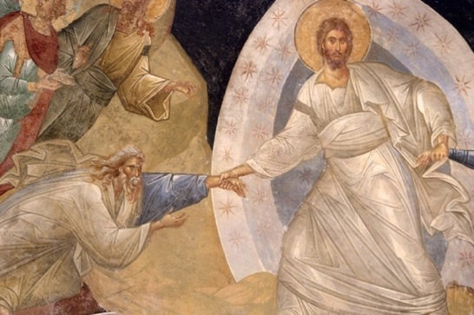

**Saturday April 30, 2022, 4:30 PM:**

**For the peace, health and salvation of**

**Rt. Rev. Edward Kakaty**

On the 50th Anniversary of his

Priestly ordination at St. Basil the Great in Utica, NY

**Sunday May 1, 2022, 11:00 AM:**

**For the repose of the souls of**

**Rt. Rev. Benedictos Abdennour,**

**Rev. Michael Jolly & Rev. Theophan Leonarczyk**

By Rev. Thomas Moses

**Rev. Saba Shofany**

By Olga Shofany and Family

**Saturday May 7, 2022, 4:30 PM:**

**For the repose of the soul of**

**Rev. Saba Shofany**

By Anthony & Sandra Showa

**Sunday March 8, 2022, 11:00 AM:**

**For the repose of the souls of**

**Rt. Rev. Charles Aboody & Rev. Clement Youssef**

By Rev. Thomas Moses

**Rose Reesh**

By Michael & Virginia Reesh Lynch

**Saturday May 14, 2022, 4:30 PM:**

**For the repose of the soul of**

**Rev. Saba Shofany**

By David & Janet George

**Jalil & Phillipine Altongy**

By Anne Altongy

**Rev. Saba Shofany**

By Astour Family

**Sunday March 15, 2022, 11:00 AM:**

**In Thanksgiving for Answered Prayers**

By the Kopyt Family

**Saturday May 21, 2022, 4:30 PM:**

**For the repose of the soul of**

**William Chanatry**

By Janet Chanatry

**Rev. Saba Shofany**

By Olga Shofany & Family

**Sunday March 22, 2022, 11:00 AM:**

**For the repose of the souls of**

**Fredrick Kopyt**

By Cheryl Kopyt & Family

**Georgia Reesh Lindfield**

By Michael & Virginia Reesh Lynch

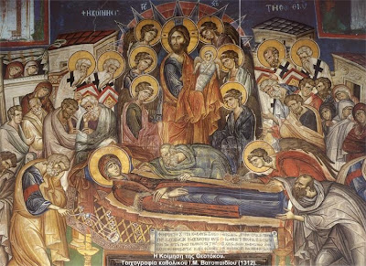

**April’s Collection:** *$3,638.82*

***Month’s Expenses:*** *$(4,535.27)*

|  |  |
| --- | --- |
| ***April’s Liturgy Attendance:*** | |
| Saturday Apr. 2: No Count | Hajme with Paschal Divine Liturgy Apr. 16: 43 |
| Sunday Apr. 3: 23 | Saturday Apr. 23: 16 |
| Palm Sunday Apr. 44: | Sunday Apr. 24: 18 |

***Announcements:***

Please, email Fr. Thomas to request prayer intentions and memorials or to discuss information and “thank you” notes to be included in future bulletins: [fatherthomasmoses@gmail.com](mailto:fatherthomasmoses@gmail.com).

**Welcome Nektaria Rose Moses!**

On Holy Thursday morning at 5:35 am, April 14, 2022, Nektaria Rose was born via ceasarian. Presbytera Rebekah is recovering well. Both baby and mama are happy and healthy. Nektaria weighed 7 lbs. 7 oz. and was 20” long when she was born. We are so grateful to you for your prayers and to God for His Providence, willing our good! Her baptism will likely take place on May 19th at Our Lady of the Cedars in Manchester, NH. If you would like to participate via live stream, let Fr. Thomas know through email and he will provide a link.

**Happy 50th Anniversary Fr. Ed Kakaty!**

Congratulations to Fr. Ed for 50 years of priestly ministry. He was ordained 50 years ago on April 30th at St. Basil the Great in Utica, NY. May God grant him many years in health and happiness!

**Rectory Facilities Maintenance Project**

With the encouragement of Bishop Nicholas, Fr. Philip, and the Parish Advisory Council, throughout March, I met with various contractors to receive quotes for replacing the windows in the church rectory. The current windows are original to the building from 1962 and haven’t been replaced. They are drafty, some are cracked, for some, the storm windows don’t work and others are covered by plexi glass and can’t be opened. The parish was also built without egresses in the bedrooms. This means that there is no easy way to escape in case of a fire. The parish heating bill is over $1,200 each month in the middle of winter and almost $8,000 per year. With permission from the Finance Council of the diocese and Bishop Nicholas plan to replace 17 windows and 1 patio door, and to enlarge the openings of one of the windows in each bedroom. The cost is estimated to be $37,500 and the project should be done by the end of June. The windows should pay for themselves over the next twenty years in saved heating costs, and even less time if the price of natural gas increases.As administrator of the parish, I am responsible for meeting the spiritual and pastoral needs of the community, but also to serve as the steward of the physical property of St. Basil the Great. I think this is a much-needed maintenance for the long term health of the parish’s infastructure.

**Update:** After a follow up discussion with Andy Astour and the contractor Jeff Peck with Sure Seal Window Installation on April 10th and 11th, we are moving forward with the window project!

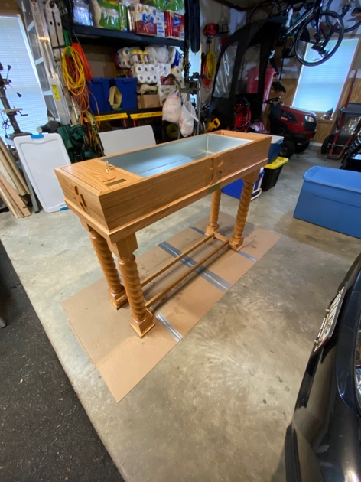**New Candle Box Commissioned**

Deacon John Fleshman, a talented hobbyist wood worker serving as deacon at Our Lady of the Cedars in Manchester, NH, is building a new candle box for veneration of the epitaphios in the kouvouklion. Deacon John is offering his labor and others are offering to contribute to the cost of wood and materials. The total cost of materials will be about $1,000. The photo is a candle box Deacon John built for OLOC. If anyone is interested in contributing, please let Fr Thomas know. Let us lift our prayers and petitions up to the Lord in our hearts, light a candle and make an offering!

**Book Recommendations**

***Beginning to Pray*** by Metropolitan Anthony Bloom

<https://store.ancientfaith.com/beginning-to-pray-metropolitan-anthony-bloom/>

***Raising Them Right A Saint's Advice on Raising Children*** By St. Theophan the Recluse

<https://www.holycross.org/collections/books-media/products/raising-them-right-a-saints-advice-on-raising-children>

***Our Thoughts Determine Our Lives: The Life and Teachings of Elder Thaddeus of Vitovnica***

<https://store.ancientfaith.com/our-thoughts-determine-our-lives/>

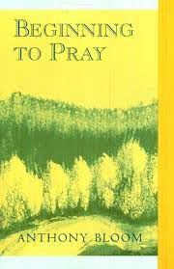 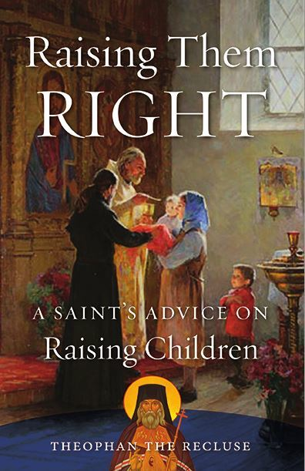 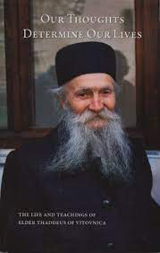



***Please remember*** to pray for the health and protection of our Bishop Nicholas and his reverend clergy, the faithful in this city of Utica and every surrounding country place, the government and the armed forces that they may be upheld and strengthened in every good deed, the parish community of St. Basil the Great Melkite Greek Catholic Church, and for all of the intentions of her friends and faithful, for Dillan, Jordan Barahmeh, Maryangela Fiorentino, Rt. Rev. Ed Kakaty, Charles Kanelos, Mary Nassimos, John Roth, Karen Zalatan, Robert Zaloom.

***If you are visiting our church***, our parish family is delighted to welcome you here! Please give us the chance to get to know you. If you would like to know more about the Melkite Catholic Church, please visit [www.melkite.org](http://www.melkite.org) or [www.godwithusonline.org](http://www.godwithusonline.org).

**Kid’s Corner:** Coloring Page and Gospel Reading

**“Sunday of the Samaritan Woman”**

**Gospel Reading:** John 5:4-32

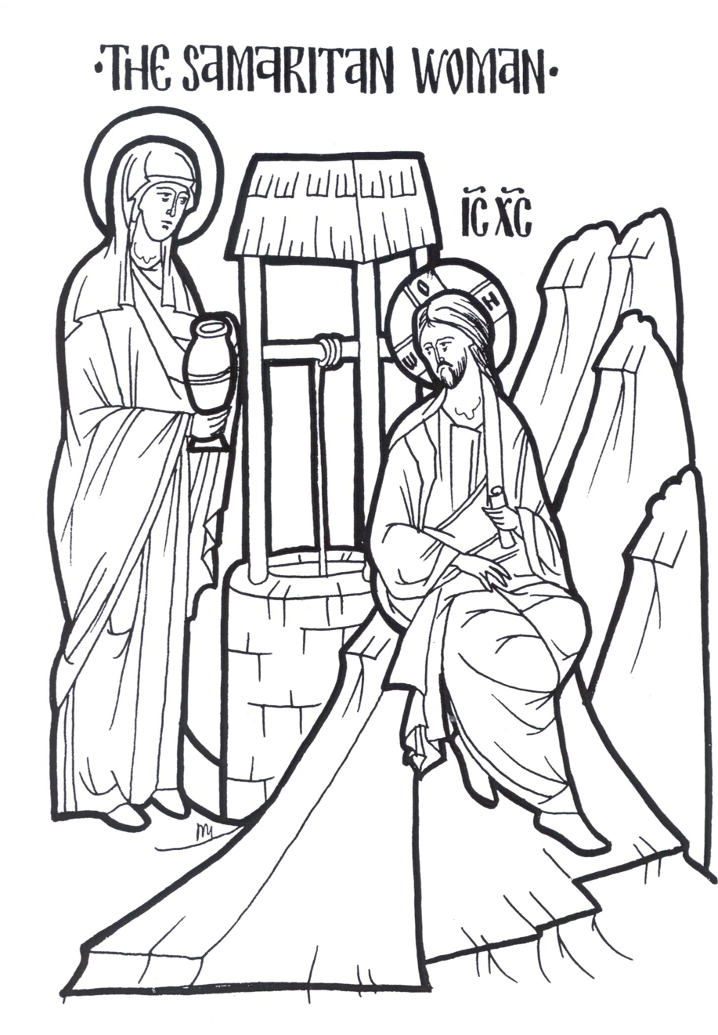 …7 A woman of Samaria came to draw water. Jesus said to her, “Give Me a drink.” 8 For His disciples had gone away into the city to buy food. 9 Then the woman of Samaria said to Him, “How is it that You, being a Jew, ask a drink from me, a Samaritan woman?” For Jews have no dealings with Samaritans. 10 Jesus answered and said to her, **“If you knew the gift of God, and who it is who says to you, ‘Give Me a drink,’ you would have asked Him, and He would have given you living water.”** 11 The woman said to Him, “Sir, You have nothing to draw with, and the well is deep. Where then do You get that living water? 12 Are You greater than our father Jacob, who gave us the well, and drank from it himself, as well as his sons and his livestock?” 13 Jesus answered and said to her, **“Whoever drinks of this water will thirst again, 14 but whoever drinks of the water that I shall give him will never thirst. But the water that I shall give him will become in him a fountain of water springing up into everlasting life.”** …

25 The woman said to Him, “I know that Messiah is coming” (who is called Christ). “When He comes, He will tell us all things.” 26 **Jesus said to her, “I who speak to you am He”**…

**“Sunday of the Paralytic:” Paralyzed by Sins and Thoughtless Acts (John 5:1-15)**

**What Does It Mean to be Paralyzed?**

In the Early Church commentators did not often speculate on the pool or even the nature of the man’s illness. It was more common to compare the physical infirmity of the paralyzed man to the spiritual paralysis which afflicts Christians, either occasionally or in a regular way. It was often noted how, in the lives of each one of us, there will be spiritual paralysis: moments of weakness or failure, which can last for many years, as with the paralytic at the sheep pool.

In “spiritual paralysis,” the energies of our soul, of our mind, of our heart, of our will, of our body itself are fettered, fettered by the fact that we have no courage and we have no power within us to move and to act to the full of our longings. We stand, year after year on the very edge, on the bank of the pool that could give us life without being able to enter it.

**Christian Life as Synergy**

In one of the last New Testament books to reach its final form, the Second Epistle of St Peter, we see the Christian spiritual life addressed. Spiritual life, we read, comes “... through the knowledge of Him who called us by glory and virtue, by whom have been given to us exceedingly great and precious promises, that through these you may be partakers of the divine nature” (2 Pt 1:3. 4). The way to theosis, being partakers of the divine nature, comes because of Christ. God become incarnate so that we might become divinized.

We, however, need to embrace this gift, lest it whither away and we become blind or paralyzed. We do this, the epistle continues, by practicing virtue, self-control, godliness, perseverance, brotherly kindness and love. “For if these things are yours and abound, you will be neither barren nor unfruitful in the knowledge of our Lord Jesus Christ. For he who lacks these things is shortsighted, even to blindness, and has forgotten that he was cleansed from his old sins” (2 Pt 1:3-9). Fruitful Christian life, then, requires that we do our part to make our own the gift of divine life we have received.

We can become shortsighted or even blind to the gift of our baptism, remaining barren and unfruitful – in other words, paralyzed – without being committed to growing in virtue, knowledge, self-control and the rest. We may see this happen in the lives of some Christians who do not consider their baptism seriously, who rarely look to the Gospel, receive the Eucharist or even attend the Liturgy. They are blind to the gift of Christ and therefore paralyzed in the spiritual life. We see it in ourselves, when we cannot focus on the words we read or even the prayers we are saying, distracted by the concerns of daily life.

**Paralysis and the Passions**

As more philosophically-minded Greeks accepted Christ, they identified the signs of spiritual paralysis in terms of the classical passions: gluttony, lust, greed, anger, envy, sloth, pride and vainglory. A person who is focused on personal comforts (through food and drink, sex or material possessions) will find it difficult if not impossible to center on the spiritual life. If they attend church at all, they find their mind wandering back to the object of their passion.

A story is told about St Basil, the revered Fool for Christ, who confronted Tsar Ivan the Terrible one day because he was not at the Liturgy. Ivan protested that he was indeed in church for the service., Basil replied that the emperor’s body was in church, but his mind was on the Vorobiev hills (where he was having a palace built). When Basil died in 1557, the Tsar acted as one of his pallbearers.

…St John Chrysostom discusses the spiritual medicines necessary to combat the passions and other distractions from the Christian life: “The divine oracles [the Scriptures] are a treasury of all manner of medicines, so that whether it be needful to quench pride, to lull desire to sleep, to tread underfoot the love of money, to despise pain, to inspire confidence, to gain patience, from them one may find abundant resource.” The Scriptures held the medicine; the illnesses were the passions.

